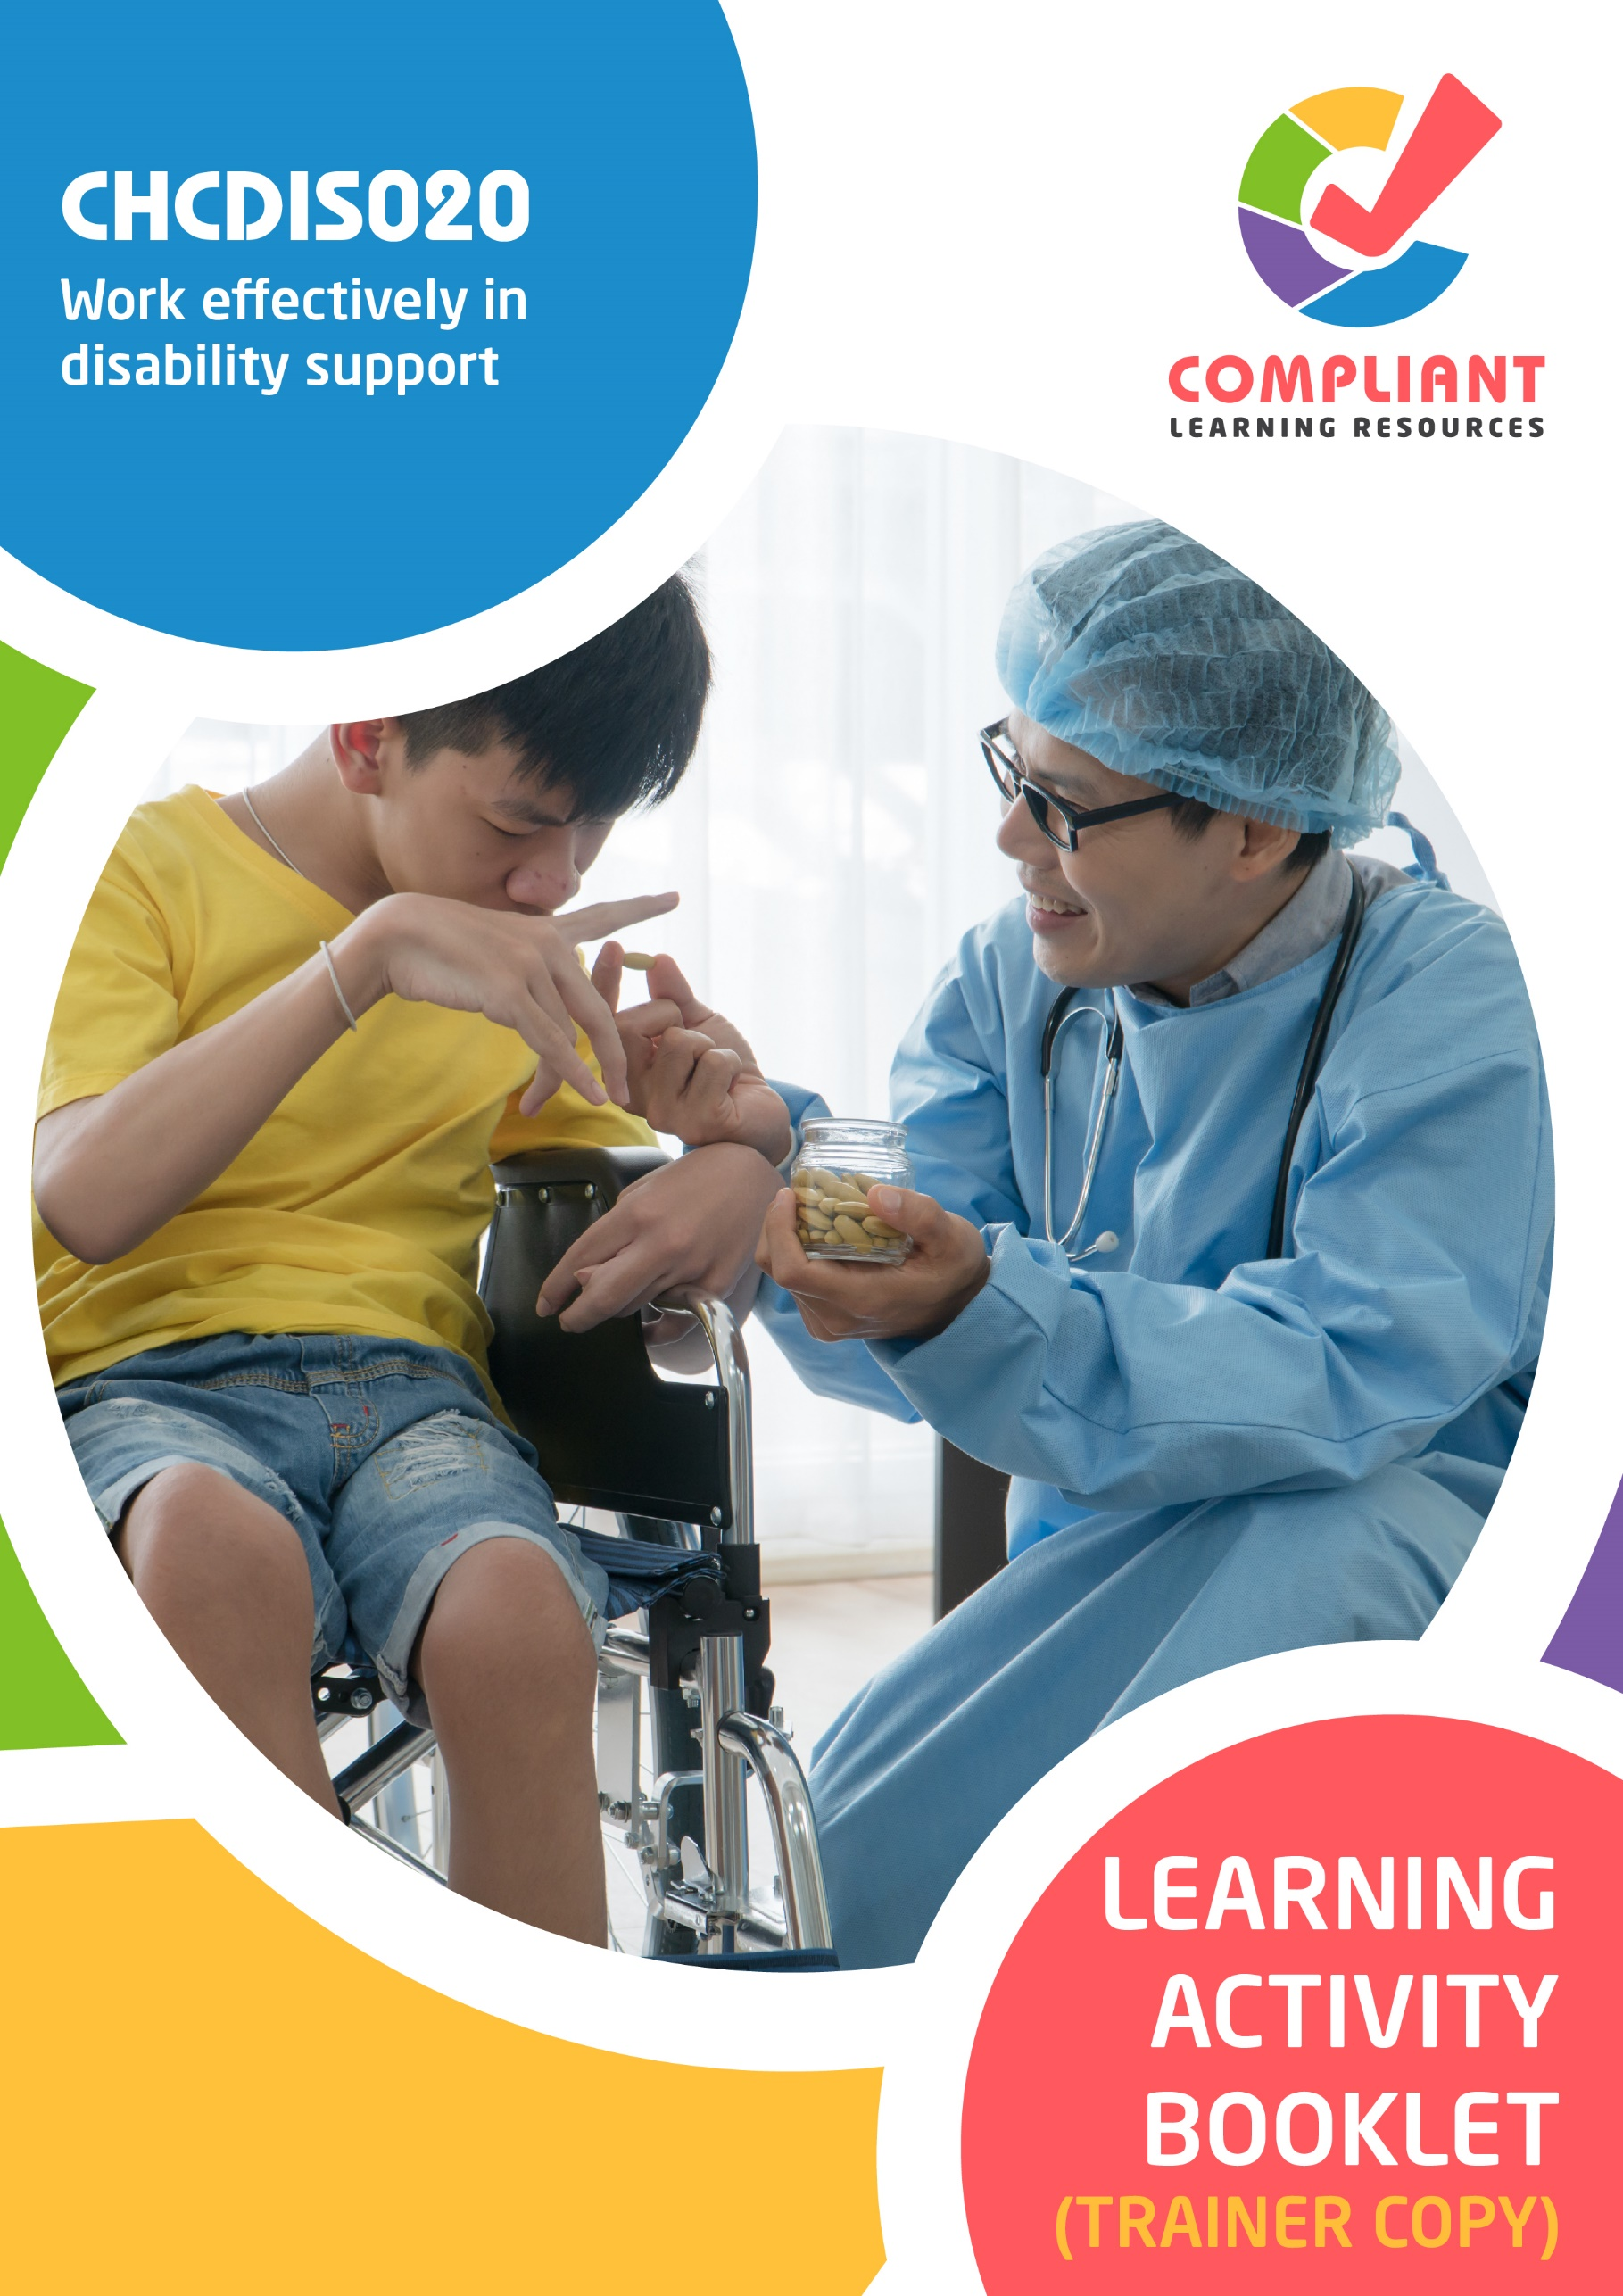

**Copyright**

This document was developed by Compliant Learning Resources.

© 2023 Compliant Learning Resources.

All rights reserved.

No part of this publication may be reproduced, stored in a retrieval system, or transmitted in any form or by any means, electronic, mechanical, photocopying, recording, or otherwise without the prior written permission of Compliant Learning Resources.

**Version Control & Document History**

|  |  |  |
| --- | --- | --- |
| **Date** | **Summary of Modifications** | **Version** |
| 11 January 2023 | Version 1.0 released for publishing | 1.0 |
| 24 August 2023 | Version 1.1 endorsed for use  Fixed wording issues | 1.1 |

# Table of Contents

Overview 4

Trainer Instructions 5

Learner Instructions 6

Learner Information 6

Trainer Information 6

Resources Required 7

Work Health and Safety 7

Reasonable Adjustment 8

Contextualisation 9

Formative Activities 10

I. Meeting the Job Requirements of a Disability Support Worker 10

Activity 1.1 10

Activity 1.2 12

Activity 1.3 13

II. Working within Organisational Requirements in Disability Support 14

Activity 2.1 14

Activity 2.2 15

Activity 2.3 16

III. Working within a Disability Support Context 17

Activity 3.1 17

Activity 3.2 18

Activity 3.3 19

# Overview

**CHCDIS020 – Work effectively in disability support (Release 1)**

This unit describes the performance outcomes, skills and knowledge required to work effectively in a disability support work context. The unit covers meeting job requirements, complying with organisational requirements and working in a disability sector context.

This unit applies to individuals who work with people with disability in a range of community services and health contexts. Work performed requires some discretion and judgement and will be carried out under regular direct or indirect supervision.

The skills in this unit must be applied in accordance with Commonwealth and State/Territory legislation, Australian standards and industry codes of practice.

No occupational licensing, certification or specific legislative requirements apply to this unit at the time of publication.

**A complete copy of the above unit of competency can be downloaded from the TGA website:**

<https://training.gov.au/Training/Details/CHCDIS020>

# Trainer Instructions

This Learning Activity Booklet contains formative activities that learners will complete in the classroom or a similar environment.

These formative activities include knowledge questions to test learners’ underpinning generic knowledge and practical activities to test their skills relevant to the unit/s of competency.

These formative assessments are used by trainers to complement both the learning and training processes, and to evaluate how learners are progressing throughout these processes.

**IMPORTANT:**

**The completion of the formative assessments and learning activities included in this workbook DOES NOT lead to a Qualification or a Statement of Attainment (SOA).**

Reasonable adjustment applies here, and while the majority of learners will complete this assessment as a written assessment, verbal assessment may be an option for those who need it. The assessor must use the marking guide as the principal marking tool unless a reasonable adjustment is demonstrated.

The Learning Activity Booklet (Trainer Copy) provides model answers to all the questions, setting out which key responses must be included as well as indicating where flexibility is acceptable.

The number of responses required is specified in each assessment task to avoid ambiguity. In these cases, the model answer will provide a list of possible answers. For instance, if a question requires the learner to list three examples, then their response must include three of the items listed in the model answer.

# Learner Instructions

This Learning Activity Booklet contains formative activities that learners will complete in the classroom or a similar environment.

These formative activities include knowledge questions to test your underpinning generic knowledge and practical activities to test your skills relevant to the unit/s of competency.

These formative assessments are used by your trainer to complement both the learning and training processes, and to evaluate how you are progressing throughout these processes.

You may reference your Learner Guide and other learning materials to complete the activities included in this workbook.

**IMPORTANT:**

**The completion of the formative assessments and learning activities included in this workbook DOES NOT lead to a Qualification or a Statement of Attainment (SOA).**

## Learner Information

|  |  |
| --- | --- |
| Learner name |  |
| Phone |  |
| Email |  |

## Trainer Information

|  |  |
| --- | --- |
| Trainer name |  |
| RTO name |  |
| RTO phone |  |
| RTO email |  |

# Resources Required

Resources needed to complete activities included in this workbook include:

* Computer with Internet, email access, and a working web browser
* Installed software: MS Word, Adobe Acrobat Reader
* Learner guide

# Work Health and Safety

Both the trainers and learners have duty of care in ensuring that the learning environment is free from hazards that may pose risks to their health and safety.

According to WHS legislation, trainers and learners must take reasonable care while undertaking the activities included in this workbook in the learning environment.

# Reasonable Adjustment

‘Reasonable adjustment’ in VET is the term applied to modifying the learning environment or making changes to the training delivered to assist a learner with a disability. A reasonable adjustment can be as simple as changing classrooms to be closer to amenities or installing a particular type of software on a computer for a person with vision impairment.

**Why make a reasonable adjustment?**

We make reasonable adjustments in VET to make sure that learners with disabilities have:

* The same learning opportunities as learners without disabilities, and
* The same opportunity to perform and complete assessments as those without disabilities.

**Reasonable adjustment applied to participation in teaching, learning, and assessment activities can include:**

* Customising resources and assessment activities within the training package or accredited course
* Modifying the presentation medium
* Learner support
* Use of assistive/adaptive technologies
* Making information accessible both before enrolment and during the course
* Monitoring the adjustments to ensure learner needs continue to be met

**Assistive/Adaptive Technologies**

Assistive/adaptive technology means ‘software or hardware that has been specifically designed to assist people with disability in carrying out daily activities’ (World Wide Web Consortium - W3C). It includes screen readers, magnifiers, voice recognition software, alternative keyboards, devices for grasping, visual alert systems, and digital note-takers.

*(Adapted Reasonable Adjustment in teaching, learning and assessment for learners with a disability - November 2010 - Prepared by - Queensland VET Development Centre)*

**IMPORTANT:**

**Reasonable adjustment made for collecting learner assessment evidence must not impact the standard expected by the workplace, as expressed by the relevant unit/s of competency. For example, if the assessment were gathering evidence of the learner’s competency in writing, allowing the learner to complete the assessment verbally would not be a valid assessment method. The method of assessment used by any reasonable adjustment must still meet the competency requirements.**

# Contextualisation

Contextualisation is the process of modifying assessment tools to make learning more meaningful for your students and their employers.

Compliant Learning Resources highly recommends that your RTO contextualise the assessment tools before using them.

You must contextualise the assessment tools to suit:

* Your student’s needs
* Your RTO’s training and assessment processes
* The work and industry context in which you operate

**Contextualising for your state/territory**

The contents of this assessment tool are not written for a specific state/territory unless stated otherwise. Where the assessment tool refers to legislation and other industry requirements, which may vary across states/territories, model answers are based on one state/territory.

Should your RTO intend to use this assessment tool for learners from your state/territory, Compliant Learning Resources recommends you to:

* Access and review the legislation and industry requirements applicable in your state/territory.
* Update assessments and benchmark answers to reflect the legislation and industry requirements applicable in your state/territory.

When you are contextualising assessment tools, you must ensure that you retain the integrity of the assessment and the outcomes of the unit of competency.

**A comprehensive guide to contextualising your assessment tools for your RTO can be accessed through this link:**

<https://compliantlearningresources.com.au/blog/simple-guide-to-contextualising-rto-training-resources-and-assessment-tools/>

# Formative Activities

## I. Meeting the Job Requirements of a Disability Support Worker

### Activity 1.1

|  |  |  |  |  |  |  |
| --- | --- | --- | --- | --- | --- | --- |
| **Matching Type**  Identify the terminology being described in each statement below.   |  | | --- | | **Disability Sector Terminology** | | Mobility | | Carer | | Core Activities | | Activities of Daily Living (ADL) | | Disability Support Worker | |
|  |
| *Mapping: CHCDIS021 PC1.1 (p)*  *Learner Guide Reference: CHCDIS021 Learner Guide, Chapter 1, Subchapter 1.1, Section 1.1.1* |

|  |  |
| --- | --- |
| Description of Terminology | |
| Disability Support Worker | 1. This person provides formal assistance for core and non-core activities. |
| Core activities | 1. These activities involve communication, self-care, and mobility. |
| Activities of Daily Living (ADL) | 1. These are fundamental tasks wherein one cares for oneself, like eating, showering, dressing up, and mobility. |
| Carer | 1. This person provides ongoing informal assistance for core and non-core activities. |
| Mobility | 1. Refers to activities such as picking up objects from the floor, walking, using stairs, using public transport, moving about, etc. |

### Activity 1.2

|  |
| --- |
| List four possible job role requirements of a disability support worker |
|  |
| *Mapping: CHCDIS021 PC1.1 (p)*  *Learner Guide Reference: CHCDIS021 Learner Guide, Chapter 1, Subchapter 1.1, Section 1.1.2*  **Marking guide**  The learner must list four possible job role requirements of a disability support worker.  For a satisfactory performance, although the wording may slightly vary, their response must include four of the following.   * Assisting the person in social and recreational activities such as going to the park or seeing a movie * Helping the person with their employment goals * Personal care such as showering, shaving, and oral hygiene * Domestic duties such as cooking and cleaning * Providing emotional support * Helping the person communicate * Handling relevant equipment such as hoists and wheelchairs |
|  |
|  |
|  |
|  |

### Activity 1.3

|  |
| --- |
| Briefly explain the importance of working within your job scope. |
|  |
| *Mapping: CHCDIS021 PC1.2 (p)*  *Learner Guide Reference: CHCDIS021 Learner Guide, Chapter 1. Subchapter 1.2*  **Marking guide**  The learner must explain the importance of working within their job scope.  For a satisfactory performance, although the wording may slightly vary, their response must be consistent with the benchmark answer below. The underlined words/phrases must appear in the learner’s response. |
| Knowing your job scope will help you maintain a safe and transparent working environment for your benefit and the person’s. Performing a task that you are unqualified for will negatively impact the person’s wellbeing.  Acting outside your job scope has consequences for those delivering National Disability Insurance Scheme (NDIS) supports and services. In the NDIS Code of Conduct, the third element states that workers must ‘provide supports and services in a safe and competent manner with care and skill. |

## II. Working Within Organisational Requirements in Disability Support

### Activity 2.1

|  |  |
| --- | --- |
| **True or False**  Review the statements below about attitudes, beliefs, and common misconceptions. Indicate whether each statement is True or False.  Tick the box that corresponds to your answer. | |
|  | |
| *Mapping: CHCDIS021 PC2.1 (p)*  *Learner Guide Reference: CHCDIS021 Learner Guide, Chapter 2, Subchapter 2.1, Section 2.1.1* | |
| TRUE  FALSE | 1. Persons with disabilities are more vulnerable to workplace injury. |
| TRUE  FALSE | 1. A healthcare professional should not interfere with the person’s ability to decide for themselves and consent. |
| TRUE  FALSE | 1. Persons with disabilities are not inferior to people without disabilities. |
| TRUE  FALSE | 1. Persons with disabilities generally have difficulty fitting in the workplace. |
| TRUE  FALSE | 1. Persons with disabilities are found to work at the same productivity levels as other employees. |

### Activity 2.2

|  |  |  |  |  |  |  |  |
| --- | --- | --- | --- | --- | --- | --- | --- |
| **Matching Type**  Identify the ethical and legal consideration being described in each statement below.   |  | | --- | | **Ethical and Legal Considerations** | | Consent | | Mandatory Reporting | | Duty of Care | | Restrictive Practices | | Dignity of Risk | | |
|  | |
| *Mapping: CHCDIS021 PC2.2 (p)*  *Learner Guide Reference: CHCDIS021 Learner Guide, Chapter 2, Subchapter 2.2, Section 2.2.2* | |
| Description | |
| Mandatory Reporting | 1. This is a legal obligation to report any reasonable belief of abuse to the proper authorities. |
| Dignity of Risk | 1. This termrefers to a person’s right to participate in activities that may come with risks. |
| Duty of Care | 1. This is a legal obligation that requires disability support workers to always act in their person’s best interests. |
| Restrictive Practices | 1. These practices sometimes take away the option of choice if that option may cause harm to themselves or others. |
| Consent | 1. This is when someone agrees or gives permission to someone else to perform a particular action. |

### Activity 2.3

|  |
| --- |
| Explain three ways on how to cooperate well with an interdisciplinary team |
|  |
| *Mapping: CHCDIS021 PC2.3 (p)*  *Learner Guide Reference: CHCDIS021 Learner Guide, Chapter 2, Subchapter 2.3*  **Marking guide**  The learner must explain three ways on how to cooperate well with an interdisciplinary team.  For a satisfactory performance, although the wording may slightly vary, their response must be consistent with the benchmark answer below. The underlined words/phrases must appear in the learner’s response. |
| You need to know your role. This means knowing what to do and doing it well. |
| Respect everyone. You need to appreciate what each member does. It also means working within your role, not taking over all the work. |
| Finally, have a group mentality, which means helping when you can. You should not overstep your boundaries, but you should also not ignore a team member who needs help. Finally, you should keep everyone updated on details about older people in your care. This is important in making sure they are receiving the best care. |

## III. Working Within a Disability Support Context

### Activity 3.1

|  |
| --- |
| Identify five types of content found in the individualised plan |
|  |
| *Mapping: CHCDIS021 PC3.1 (p)*  *Learner Guide Reference: CHCDIS021 Learner Guide, Chapter 3, Subchapter 3.1*  **Marking guide**  The learner must identify content found in the individualised plan.  For a satisfactory performance, although the wording may slightly vary, their response must include five of the following.   * The person’s basic information (name, history, condition, allergies if any). * The person’s holistic needs (physical, emotional, psychological, and spiritual). * The person’s wants and preferences. * The person’s goals in terms of their holistic needs. * The person’s support schedule. This includes tasks, frequency of tasks, and equipment needed. * The sources of funding for the person’s needs and the total budget for these. * Strategies for supporting and empowering the person to meet their holistic needs. * The person’s behaviour(s) of concern, if any. * Other information such as medication, the specialist personnel to contact when the need arises. |
|  |
|  |
|  |
|  |
|  |

### Activity 3.2

|  |
| --- |
| **Fill in the blanks**  The following are statements about person-centred communication techniques. Review each and complete the statement by filling in the missing words/phrases. |
|  |
| *Mapping: CHCDIS021 PC3.2 (p)*  *Learner Guide Reference: CHCDIS021 Learner Guide, Chapter 3, Subchapter 3.2, Section 3.2.3* |
| 1. The goal of the collaboration is to have a       win-win solution. This means that both parties’ thoughts and opinions must be considered and must be able to settle down, satisfying both ends. |
| 1. Confrontation is an approach wherein you       directly tell a person your feelings, emotions, and what you want to happen. This happens when there is a       face-to-face encounter with another person to inform them of what they do not want to hear. |
| 1. Motivational Interviewing is a person-centred communication technique where one can make       clarifications about statements, build       confidence in the person, and motivate the person to keep positive habits and make positive changes. |
| 1. Using the coercive approach often       disregards the needs and goals of the person. People who use this approach assume what the person means, take complete       control of the conversation, and       impose alternatives instead of letting the person choose. |
| 1. You can get detailed information beyond       ‘yes’ or ‘no’ with open-ended questions. This method upholds a person-centred approach since it allows the person to lead the conversation. |

### Activity 3.3

|  |  |
| --- | --- |
| **True or False**  Review the statements below about seeking consent from the person, carer, family, and others for support activities. Indicate whether each statement is True or False.  Tick the box that corresponds to your answer. | |
|  | |
| *Mapping: CHCDIS021 PC3.3 (p)*  *Learner Guide Reference: CHCDIS021 Learner Guide, Chapter 3, Subchapter 3.3* | |
| TRUE  FALSE | 1. You need to use certain strategies for people who do not have a conventional means of communicating. These may include sign language, braille, drawings, etc. |
| TRUE  FALSE | 1. Support activities are activities wherein the disability support worker assists the person in their daily life. |
| TRUE  FALSE | 1. The carer is the principal person who will give consent. |
| TRUE  FALSE | 1. Valid consent is voluntary, informed, specific, and current. |
| TRUE  FALSE | 1. Substitute decision-making is when a legally appointed person makes decisions on behalf of the person if the person is unable to give consent. |

## IV. Implementing Self-care Strategies

### Activity 4.1

|  |
| --- |
| List five examples of self-care strategies. |
|  |
| *Mapping: CHCDIS020 PC4.2 (p)*  *Learner guide reference: CHCDIS020 Learner Guide, Chapter 4, Subchapter 4.2*  **Marking guide**  The learner must list five examples of self-care strategies.  Responses may vary. For a satisfactory performance, their response must be activities that maintain one’s physical, emotional and mental wellbeing.  Model answers are provided below: |
| Exercising |
| Expressing gratitude |
| Getting enough sleep |
| Spending time with family |
| Eating healthy food |

### Activity 4.2

|  |  |
| --- | --- |
| **True or False**  Review the statements below about implementing self-care strategies. Indicate whether each statement is True or False.  Tick the box that corresponds to your answer. | |
|  | |
| *Mapping: CHCDIS020 PC4.1 (p). PC4.2 (p)*  *Learner guide reference:*   * *CHCDIS020 Learner Guide, Chapter 4, Subchapter 4.1* * *CHCDIS020 Learner Guide, Chapter 4, Subchapter 4.2* | |
| TRUE  FALSE | 1. Rapid breathing, tensed muscles and nausea are physical signs of stress. |
| TRUE  FALSE | 1. Workplace stress can be a source of demotivation. |
| TRUE  FALSE | 1. Self-care refers to the practice of doing things to maintain one’s physical, emotional and mental wellbeing. |
| TRUE  FALSE | 1. Seeking support from other people is an opportunity for you to share your struggles with othes. |
| TRUE  FALSE | 1. A person conducting a business undertaking is not required by law to protect their employees from psychological risks. |

End of Document